A PROJECT REPORT

ON
FACE RECOGNITION SYSTEM USING PRINCIPAL COMPONENT ANALYSIS
AND

EIGEN FACES APPROACH

DEPARTMENT OF SCEE (SIGNAL PROCESSING AND COMMUNICATION)
IIT MANDI

SUBMITTED BY-- SUBMITTED TO--

ANKIT KATIYAR-(T19137) Dr. RAMESHWAR PRTAP

Abstract

This project mainly addresses the building of face recognition system by using Principal Component Analysis (PCA). PCA is a statistical approach used for reducing the number of variables in face recognition. In PCA, every image in the training set is represented as a linear combination of weighted eigenvectors called eigenfaces. These eigenvectors are obtained from covariance matrix of a training image set. The weights are found out after selecting a set of most relevant Eigenfaces. Recognition is performed by projecting a test image onto the subspace spanned by the eigenfaces and then classification is done by measuring minimum Euclidean distance.

Contents:

- Data preprocessing

- Principal Component Analysis (PCA)

- Eigen Face Approach

- Recognition Step

- Application

FLOW-CHART
Create the Training and
Testing dataset
Predict the output based
On minimum distance
Teast image
PCA to get the eigen
faces

Project the test and training image on
Eigen faces space and calculate
the euclidian distance

Training images

- Data preprocessing

In this project we are dealing with 400 images having 40 classes and
each class has similar 10 images. After it we splits the test and train images randomly,now we
have 75% training images and 25% test images. Now we apply the PCA on training data.

- Principal Component Analysis (PCA)

PCA is a variable reduction procedure and useful when obtained data have some redundancy. This will result into reduction of variables into smaller number of variables which are called Principal Components which will account for the most of the variance in the observed variable. Problems arise when we wish to perform recognition in a high-dimensional space. Goal of PCA is to reduce the dimensionality of the data by retaining as much as variation possible in our original data set. On the other hand dimensionality reduction implies information loss. The best low-dimensional space can be determined by best principal components. The major advantage of PCA is using it in eigenface approach which helps in reducing the size of the database for recognition of a test images. The images are stored as their feature vectors in the database which are found out projecting each and every trained image to the set of Eigen faces obtained. PCA is applied on Eigen face approach to reduce the dimensionality of a large data set.

- Eigen Face Approach

The Eigen faces are Principal Components of a distribution of faces, or equivalently, the Eigen vectors of the covariance matrix of the set of the face images, where an image with N by N pixels is considered a point in N 2 dimensional space. Previous work on face recognition ignored the issue of face stimulus, assuming that predefined measurement were relevant and sufficient. This suggests that coding and decoding of face images may give information of face images emphasizing the significance of features. These features may or may not be related to facial features such as eyes, nose, lips and hairs. We want to extract the relevant information in a face image, encode it efficiently and compare one face encoding with a database of faces encoded similarly. A simple approach to extracting the information content in an image of a face is to somehow capture the variation in a collection of face images. We wish to find Principal Components of the distribution of faces, or the Eigen vectors of the covariance matrix of the set of face images. Each image location contributes to each Eigen vector, so that we can display the Eigen vector as a sort of face. Each face image can be represented exactly in terms of linear combination of the Eigen faces. The number of possible Eigen faces is equal to the number of face image in the training set. The faces can also be approximated by using best Eigen face, those that have the largest Eigen values, and which therefore account for most variance between the set of face images. The primary reason for using fewer Eigen faces is computational efficiency.
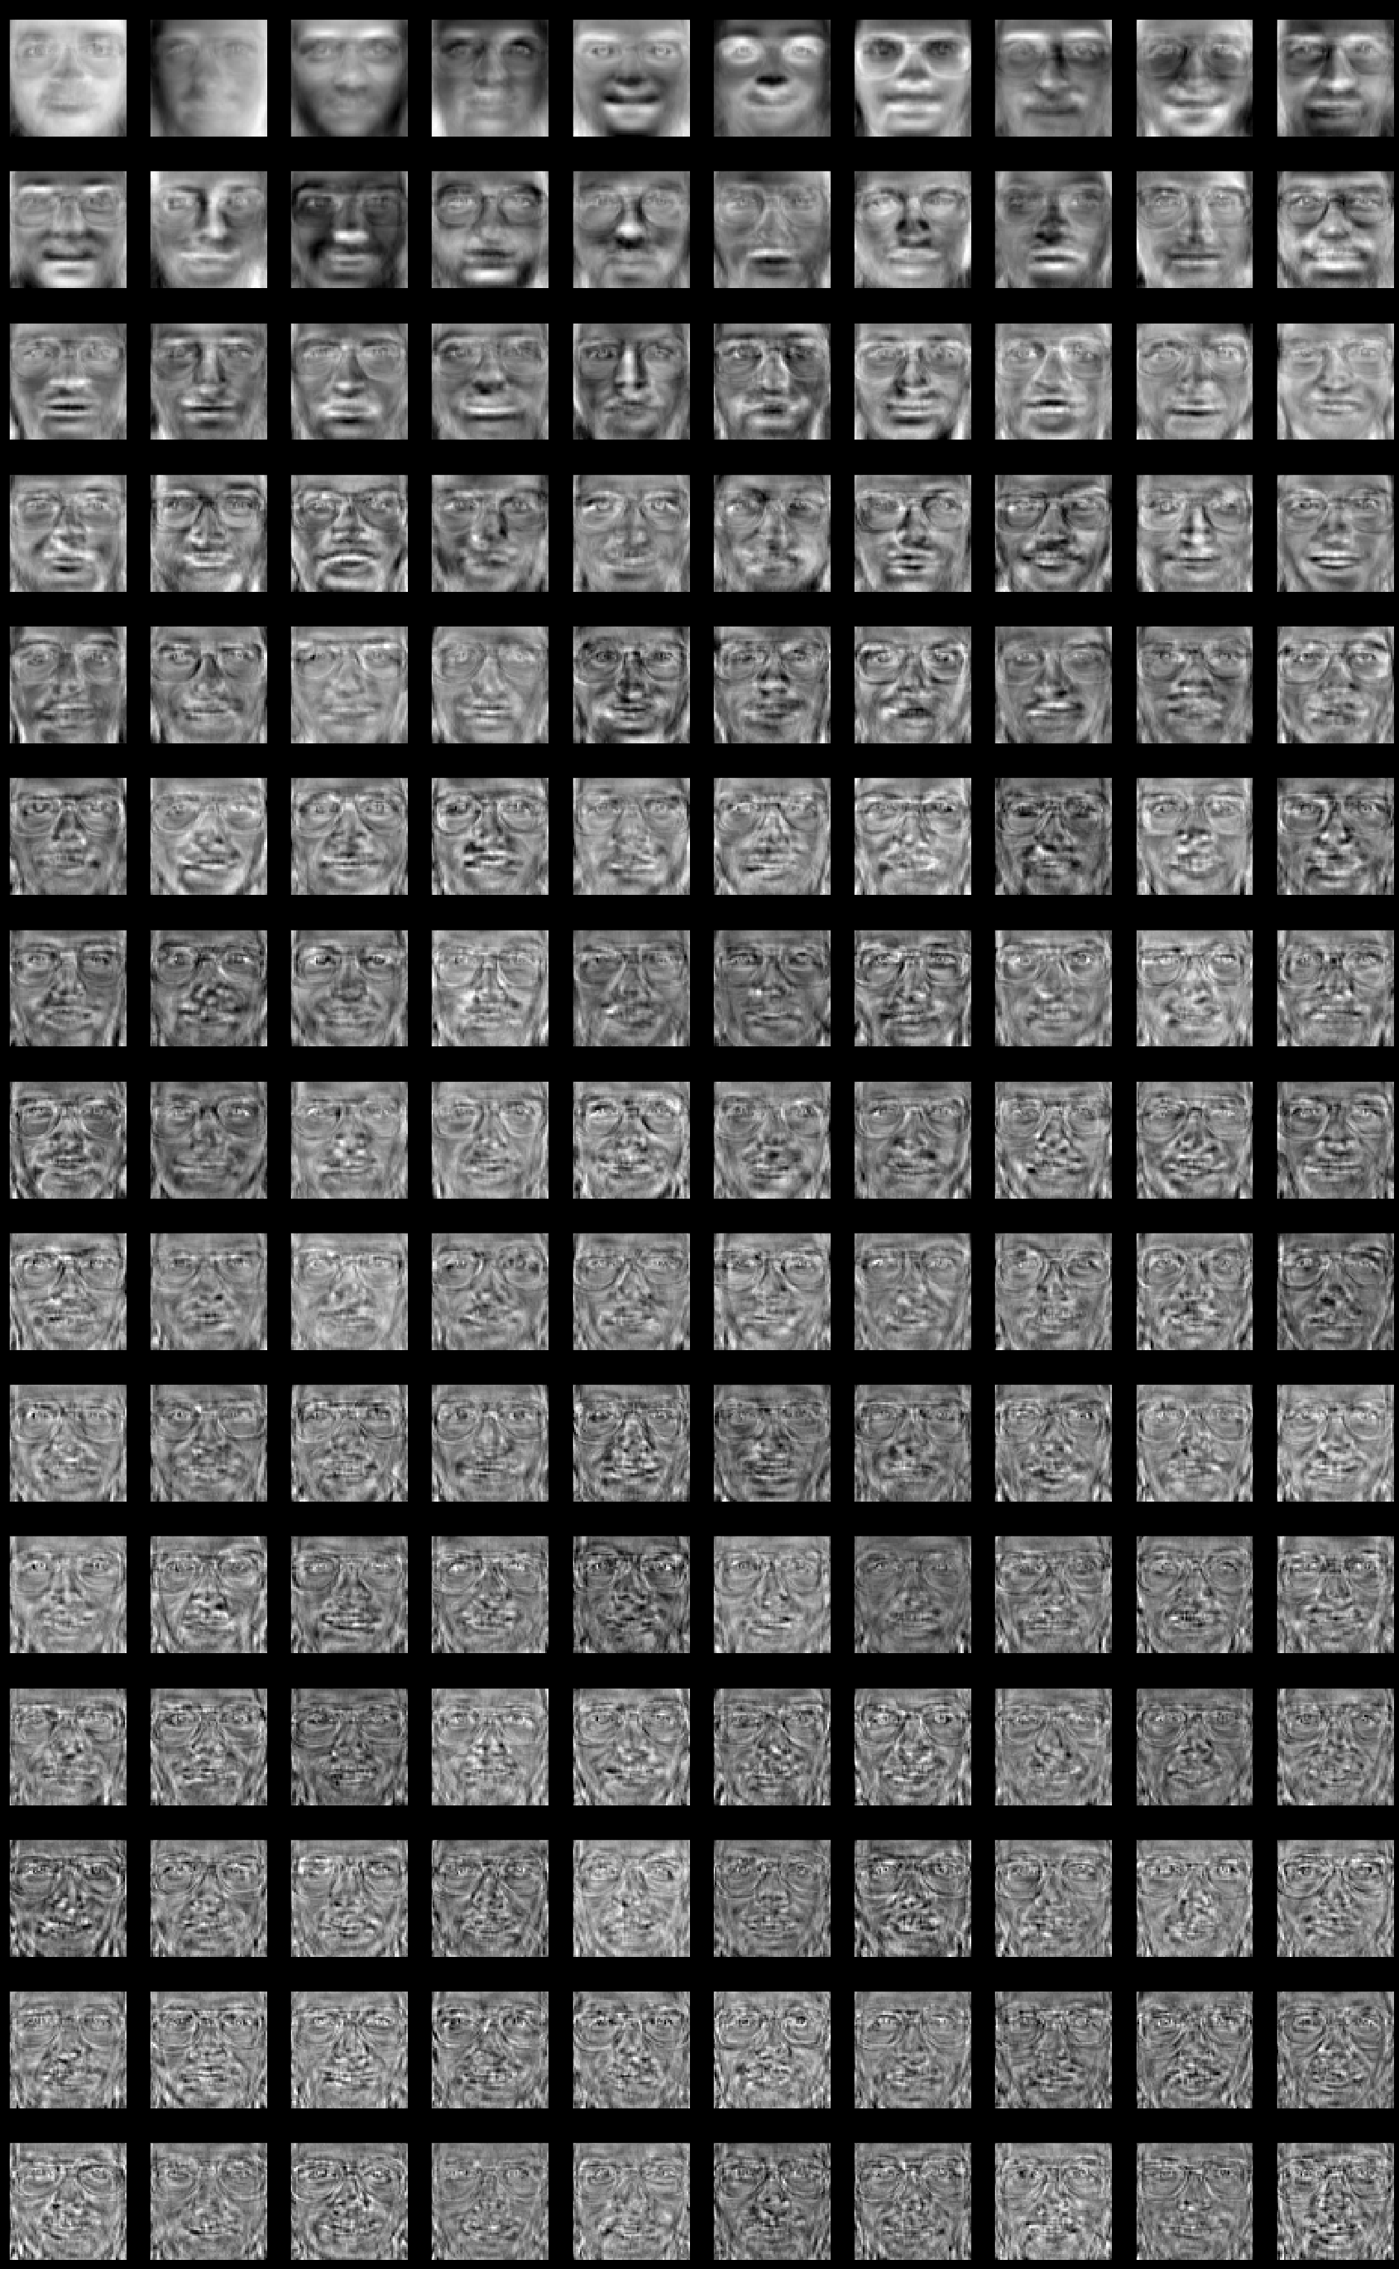
Eigen faces which contains maximum varience of the image:

here we have only 150 eigen faces which contains the 95% of varience of the training images we can reconstruct the any training image with the help of the leniear combination of these eigen faces.

- Recognition Step

The test images, Γ, is projected onto the face space to obtain a vector, Ω as Ω = U T (Γ − Ψ) The distance of Ω to each face is called Euclidean distance and defined by eps(k)^2= ||Ω − Ωk||^2 ; k = 1,,M where Ωk is a vector describing the k th face class. A face is classified as belonging to class k when the eps(k)^2 is minimum.

The Initial process involves the following steps:
i. take the initial data set of face images called as training set.
ii. Calculate Eigenfaces from the training data set, keep only the highest eigenvalues. These image define the face space. If new faces are comes, then eigenfaces can be updated or recalculated.
iii. Calculate distribution in this M-dimensional space for each known person by projecting his or her face images onto this face-space. These operations can be performed from time to time whenever there is a free excess operational capacity. This data can be cached which can be used in the further steps eliminating the overhead of re-initializing, decreasing execution time thereby increasing the performance of the entire system

Having initialized the system, the next process involves the steps:
i. Calculate a set of weights based on the input image and the M eigenfaces by projecting the input image onto each of the Eigenfaces.
ii. Determine if the image is a face at all (known or unknown) by checking to see if the image is sufficiently close to a ―free space‖.
iii. If it is a face, then classify the weight pattern as either a known person or as unknown.
iv. Update the eigenfaces or weights as either a known or unknown, if the same unknown person face is seen many times then calculates the characteristic weights.

- Application

It have one best application in crime branch where we have number of images of criminals and suppose we have new image of criminal and we want to serch it in our data and wants its record .it have two major advantage one is that it store the large data in less storage (using PCA).

Tested image and its prediction:
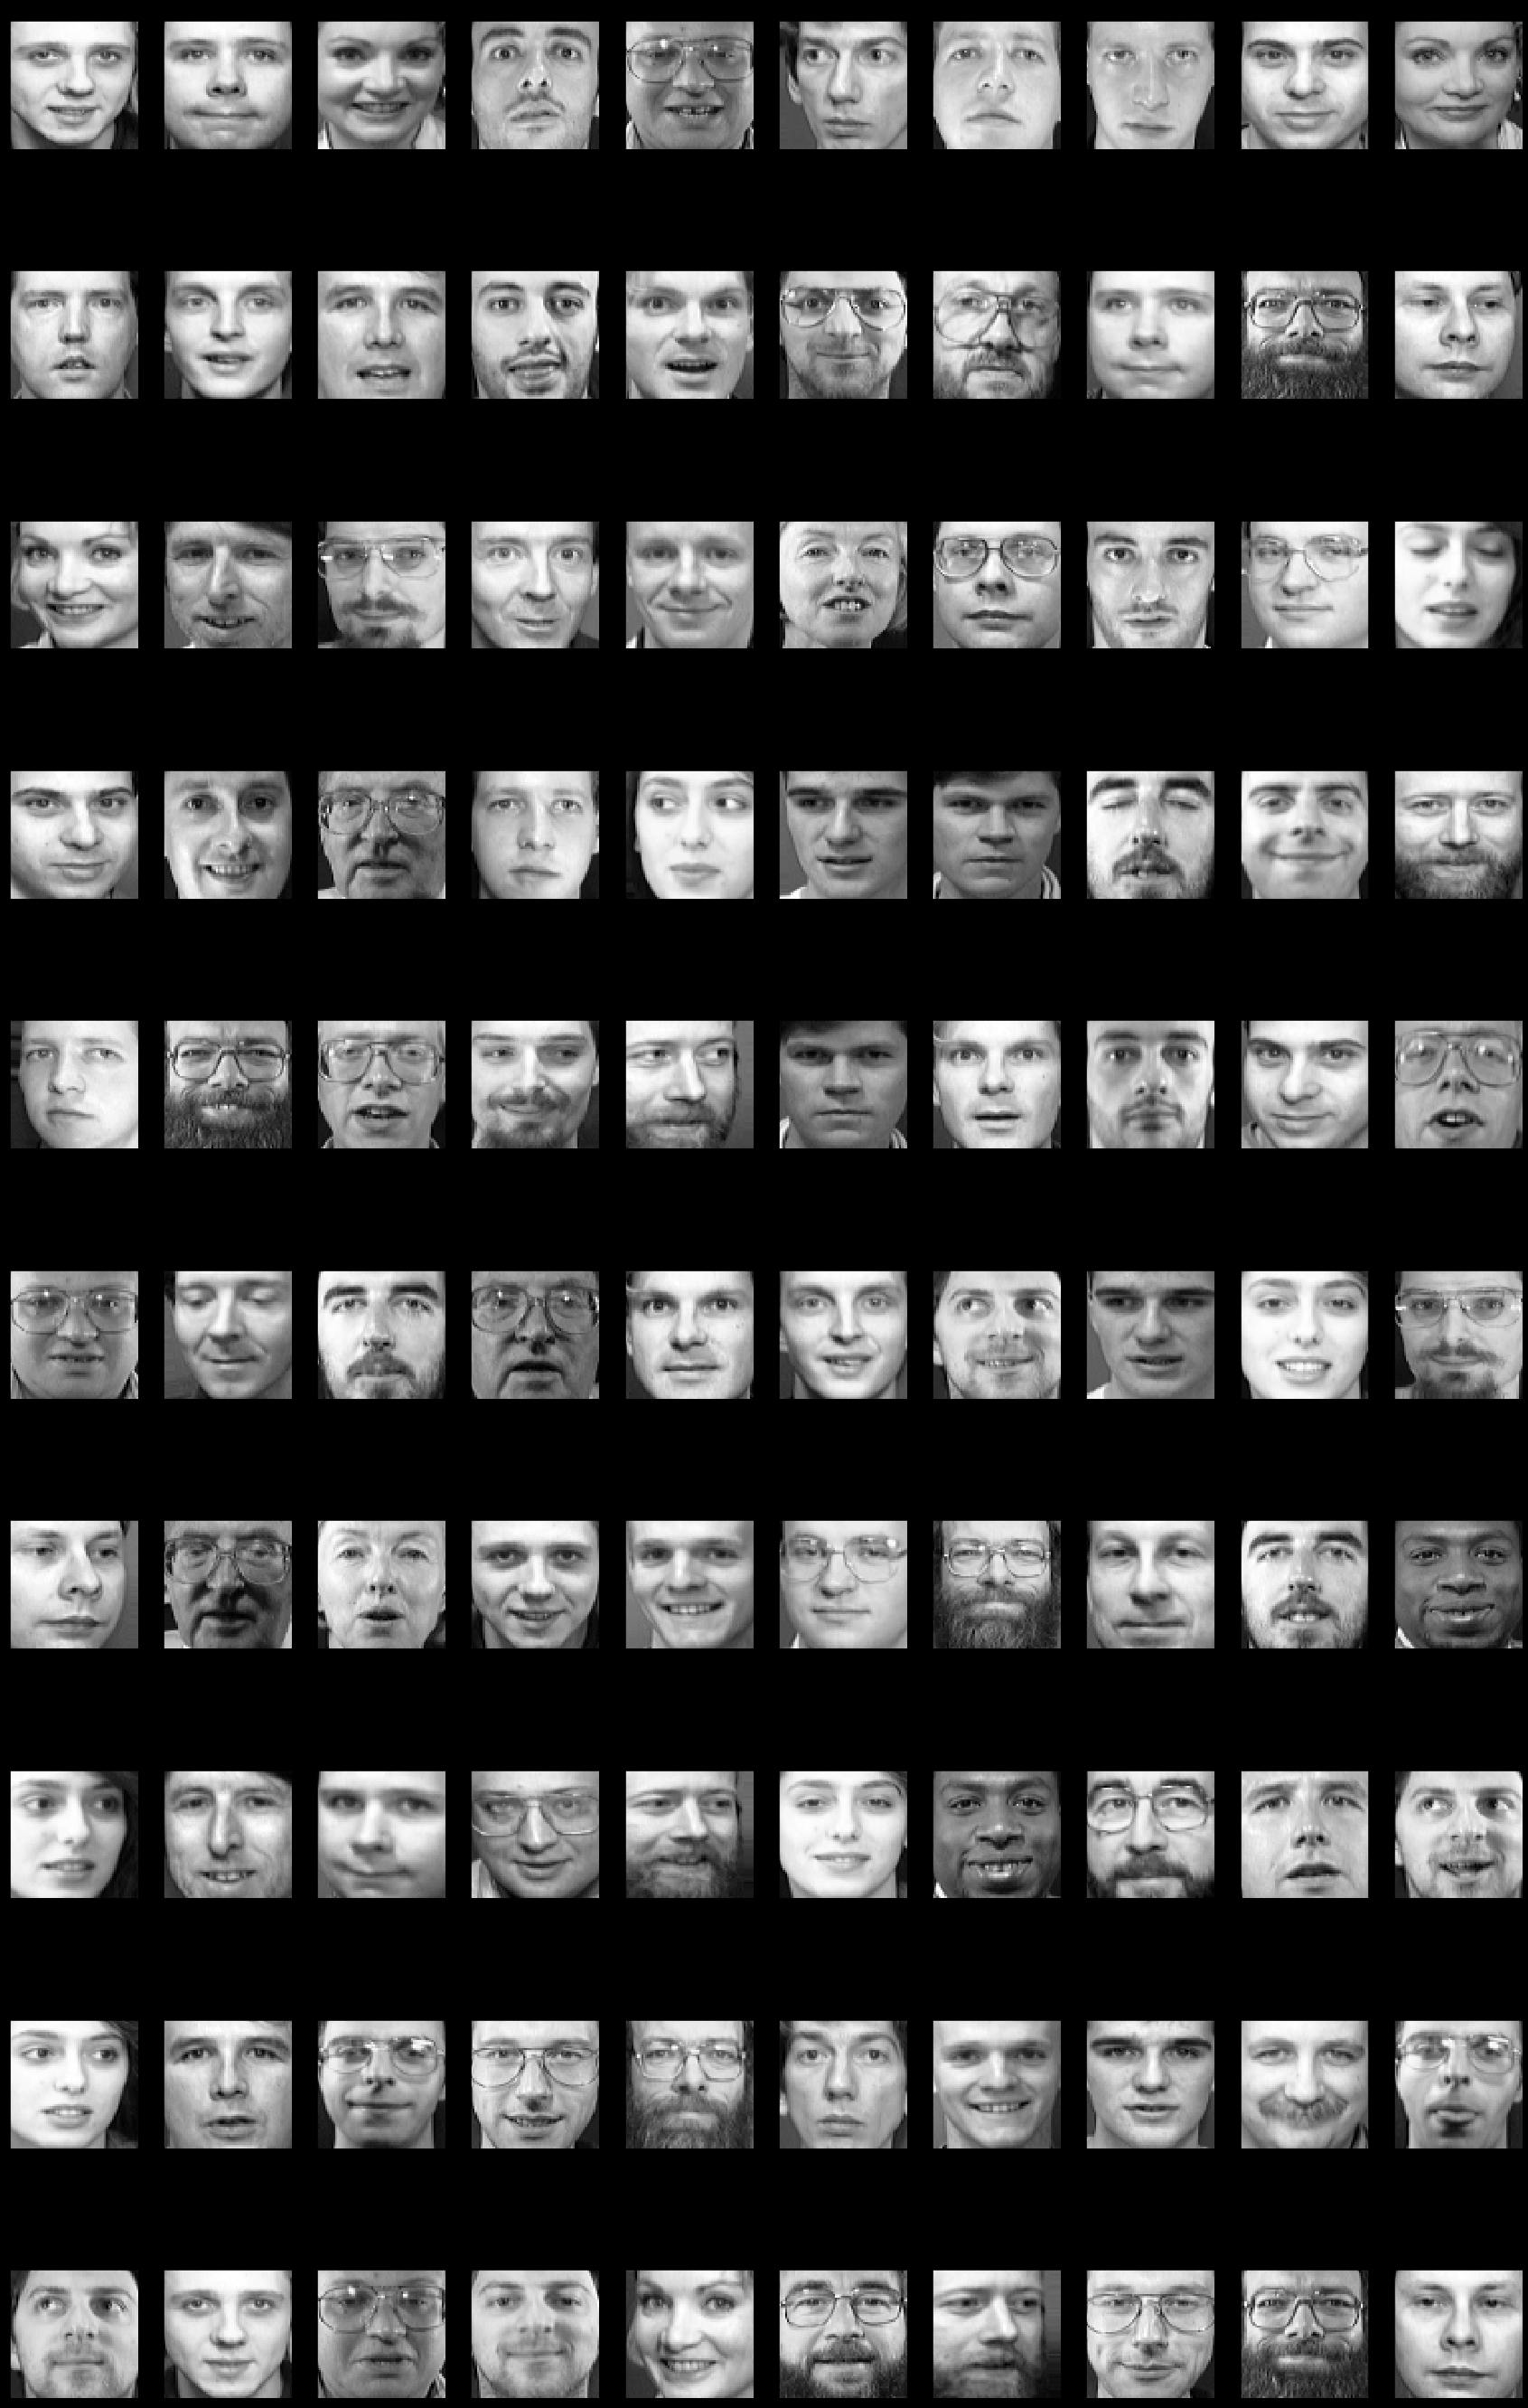

prediction of test images:
RESULT(1)
Predicting people's names on the test set
['IMG9', 'IMG11', 'IMG8', 'IMG36', 'IMG24', 'IMG8', 'IMG29', 'IMG12', 'IMG1', 'IMG29', 'IMG34', 'IMG4', 'IMG23', 'IMG7', 'IMG16', 'IMG24', 'IMG14', 'IMG5', 'IMG10', 'IMG6', 'IMG16', 'IMG10', 'IMG30', 'IMG13', 'IMG25', 'IMG35', 'IMG12', 'IMG35', 'IMG3', 'IMG39', 'IMG16', 'IMG33', 'IMG39', 'IMG18', 'IMG21', 'IMG27', 'IMG27', 'IMG8', 'IMG25', 'IMG28', 'IMG39', 'IMG17', 'IMG35', 'IMG18', 'IMG18', 'IMG15', 'IMG13', 'IMG31', 'IMG24', 'IMG21', 'IMG16', 'IMG23', 'IMG1', 'IMG13', 'IMG36', 'IMG17', 'IMG3', 'IMG27', 'IMG29', 'IMG38', 'IMG7', 'IMG35', 'IMG12', 'IMG4', 'IMG20', 'IMG4', 'IMG8', 'IMG5', 'IMG4', 'IMG23', 'IMG39', 'IMG3', 'IMG0', 'IMG17', 'IMG24', 'IMG7', 'IMG21', 'IMG24', 'IMG33', 'IMG14', 'IMG29', 'IMG1', 'IMG22', 'IMG24', 'IMG39', 'IMG34', 'IMG30', 'IMG29', 'IMG24', 'IMG7', 'IMG32', 'IMG16', 'IMG21', 'IMG2', 'IMG39', 'IMG15', 'IMG10', 'IMG14', 'IMG31', 'IMG38', 'not matched', 'not matched']
ACCURACY when we take principal component20
75.0%

1
​
RESULT(2)
Predicting people's names on the test set

1
2
3
4
5
6
7
8
9
10
11
['IMG33', 'IMG7', 'IMG22', 'IMG12', 'IMG24', 'IMG18', 'IMG23', 'IMG23', 'IMG0', 'IMG4', 'IMG11', 'IMG0', 'IMG25', 'IMG1', 'IMG38', 'IMG6', 'IMG31', 'IMG21', 'IMG9', 'IMG25', 'IMG37', 'IMG28', 'IMG26', 'IMG5', 'IMG39', 'IMG31', 'IMG9', 'IMG17', 'IMG38', 'IMG25', 'IMG15', 'IMG13', 'IMG29', 'IMG28', 'IMG15', 'IMG24', 'IMG29', 'IMG32', 'IMG13', 'IMG20', 'IMG27', 'IMG38', 'IMG36', 'IMG18', 'IMG33', 'IMG20', 'IMG4', 'IMG26', 'IMG28', 'IMG16', 'IMG5', 'IMG10', 'IMG35', 'IMG0', 'IMG20', 'IMG37', 'IMG37', 'IMG1', 'IMG16', 'IMG28', 'IMG33', 'IMG31', 'IMG20', 'IMG22', 'IMG26', 'IMG35', 'IMG7', 'IMG31', 'IMG27', 'IMG31', 'IMG34', 'IMG26', 'IMG33', 'IMG22', 'IMG20', 'IMG23', 'IMG27', 'IMG17', 'IMG7', 'IMG29', 'IMG5', 'IMG24', 'IMG30', 'IMG1', 'IMG5', 'IMG18', 'IMG21', 'IMG35', 'IMG1', 'IMG13', 'IMG14', 'IMG39', 'IMG20', 'IMG29', 'IMG23', 'IMG19', 'IMG10', 'IMG39', 'IMG7', 'IMG35', 'not matched', 'not matched']
ACCURACY when we take principal component100
86.0%

RESULT(3)
Predicting people's names on the test set
['IMG29', 'IMG15', 'IMG37', 'IMG12', 'IMG8', 'IMG6', 'IMG4', 'IMG15', 'IMG28', 'IMG23', 'IMG7', 'IMG11', 'IMG22', 'IMG29', 'IMG22', 'IMG18', 'IMG24', 'IMG9', 'IMG19', 'IMG20', 'IMG18', 'IMG20', 'IMG31', 'IMG19', 'IMG24', 'IMG26', 'IMG14', 'IMG26', 'IMG28', 'IMG17', 'IMG14', 'IMG37', 'IMG21', 'IMG29', 'IMG6', 'IMG26', 'IMG39', 'IMG11', 'IMG1', 'IMG36', 'IMG0', 'IMG30', 'IMG39', 'IMG18', 'IMG21', 'IMG18', 'IMG4', 'IMG3', 'IMG8', 'IMG23', 'IMG25', 'IMG27', 'IMG8', 'IMG3', 'IMG27', 'IMG21', 'IMG26', 'IMG16', 'IMG13', 'IMG13', 'IMG38', 'IMG39', 'IMG24', 'IMG3', 'IMG17', 'IMG20', 'IMG0', 'IMG16', 'IMG25', 'IMG21', 'IMG36', 'IMG17', 'IMG23', 'IMG9', 'IMG1', 'IMG21', 'IMG23', 'IMG14', 'IMG3', 'IMG2', 'IMG24', 'IMG7', 'IMG31', 'IMG13', 'IMG15', 'IMG28', 'IMG1', 'IMG33', 'IMG33', 'IMG3', 'IMG13', 'IMG20', 'IMG35', 'IMG27', 'IMG20', 'IMG7', 'IMG4', 'IMG38', 'IMG29', 'IMG0', 'not matched', 'not matched']
ACCURACY when we take principal component150
85.0%

- CONCLUSION

In this project we implemented the face recognition system using Principal Component Analysis and Eigen faces approach. The system successfully recognized the human faces and worked better in different conditions of face orientations.

ALGO-PROCEDURE
START
End
Prepairing a training face data base
Compute the average face vector
Keep only k eigen vector(corresponding to maximum eigen value)
Find the face class with minimum euclidean distance which shows similarity with test image
Subtract the average face vector from the original images
Calculate the feature weight for test image
Calculate feature weight for training image
Read the testing face image
Compute the euclidean distance between test feature vector with the all test feature vector
Calculate the covarience matrics

